Create a new react project : webtemplate

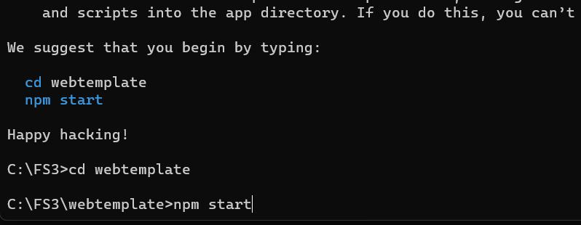

We will use a template which we had already used in assignment 3

[CLICK HERE TO DOWNLOAD TEMPLATE](https://drive.google.com/file/d/1sD0E5xfboMCRQWdI65k493yLZ3sJ5kmX/view?usp=sharing)

Extract above template

Copy and Paste CSS / Js / Asset folder in public.html of our react project.

Above template to → public folder of our react project

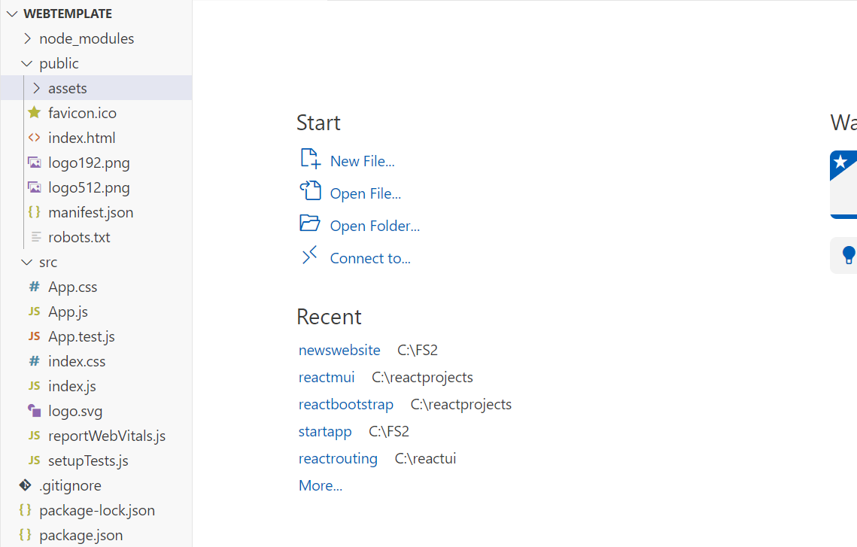

Open code of index.html and include all css and js from head and bottom of the template in index.html of our project ( in public folder )

( Include all the css and js file from head and from bottom of the template. )

Create folder pages

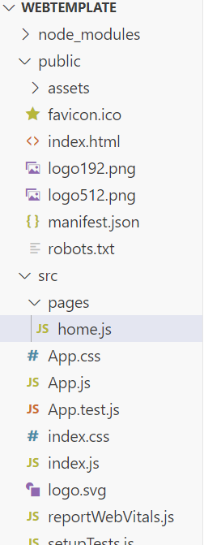

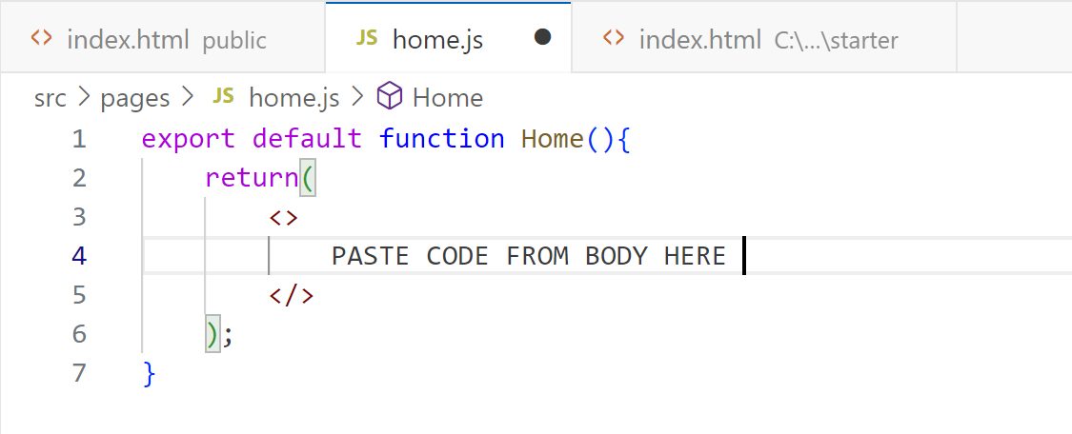

Import it in App.js and use it.

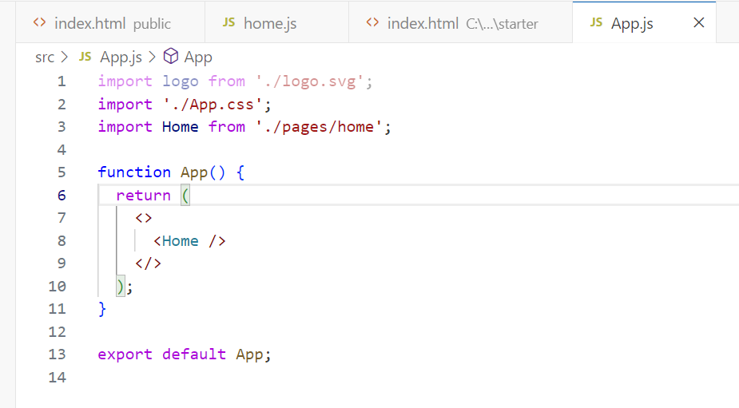

OUTPUT ON REACT SERVER :



**LOAD ALL PAGES ON BY ONE AND CHECK THE OUTPUT**

It will take time initially, after practice it will be a normal and faster process.